**1 - click on correct combination**

a - byte int long short

b - float char

c - double float boolean

d - char and boolean

Ans:

1. Byte, int, long, short.

Reason : We can covert data type from byte to short to int to long

**2 - Java save all object in which memory structure**

a - Heap

b - stack

c - queue

d - Graph

**Ans :**

1. Heap

as heap assign different memory allocation to different object

**3 – write 2 ways to create infinite loop?**

**Answer and Why? :**

**4 – Method Overloading is a kind of**

a – Compile Time Polymorphism

b – Runtime Polymorphism

c - Encapsulation

d – a and b both

**Ans:**

a – Compile Time Polymorphism

In method overloading, we use same method name but different parameter return type.

If we give same method name and same parameter then it will give error while compiling

**5 – What is the output?**

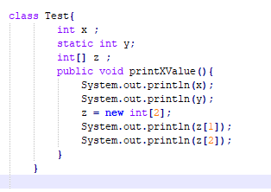

**Ans:**

**It will error as there is no main method found**

**6 – Write Sequence to initialize blocks**

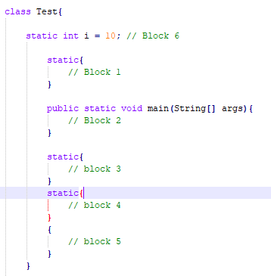

**Answer and Why? :**

**6,1,3,4,2,5**

**7 – Write Output of this Code**

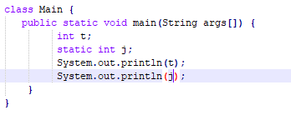

**Output :**

**It will give error while printing t variable**

**We can use only static variable in static method**

**8 - Write difference between**

A - while, do…while and for loop.

**While loop : when we don’t limit till we have to execute**

**For loop: When we know exact iteration count**

**Do while loop : execute loop atleast once.**

B – Encapsulation and Abstraction

**Encapsulation :**

|  |  |  |
| --- | --- | --- |
| Sr no. | Encapsulation | Abstraction |
| 1 | Hiding data and code in single unit to protect data from outside world | Hiding unwanted data and give essential/ relevant data |
| 2 | Encapsulation means hiding data by using gettrrs and setters errors | display errors of each statement one by one, and easier to detect errors. |
|  |  |  |

C – JDK and JRE

|  |  |  |
| --- | --- | --- |
| Sr. no | JDK | JRE |
| 1 | JDK consist of Complier and interpreter | JRE consist of only interpreter |

D – Logical AND and bitwise AND

|  |  |  |
| --- | --- | --- |
| Sr. no. | Logical AND | bitwise AND |
| 1 | Logical operator work on Boolean expression and return boolean value (true or false) | Bitwise operator works on binary digits of integer and return integer value |
| 2 | && operator evaluates the second expression only if the first one is true | & operator evaluates both condition |
|  |  |  |

**9 – What is result of below questions**

**X = 10**

**a –** Y = X++ + ++X + ++X + X++ + X++

Y= 10+12+13+13+14 = 62

b – Y = X-- + --X + ++X +X++ + ++X

**Y = 10+8+9+9+11= 47**

c – Y = X+++++X

**Y = 10+12 = 22**

**10 – Result of Below Question**

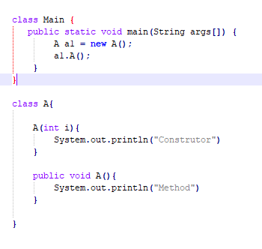

**Answer :**

**It will give error as constructed already created. We have to pass parameter in main class as we have pass parameter while creating constructor in class A**